Name:  Teacher: | ____________________________________  ________________ |  | Date:_________
 | Year 9 Mathematics  SCORE:  / 28  Topic – Non-Linear Equations  Full working out MUST be shown to get full marks for each question.
Total Time: | 30 minutes
Weighting: | 8 %
Equipment: | To be provided by the student: Pens and Pencils, scientific calculator, A4 page of notes.

1. Consider the following two equations: y=2x² and y=2^{x} [2, 6, 1, 2 - 11 marks]

- Complete the table below using the equation y=2x²
x | -2 | -1 | 0 | 1 | 2
y

- For the equation y=2^{x} we are given the completed table of values
x | -2 | -1 | 0 | 1 | 2
y | 0.25 | 0.5 | 1 | 2 | 4

- Plot these two graphs on the cartesian plane below
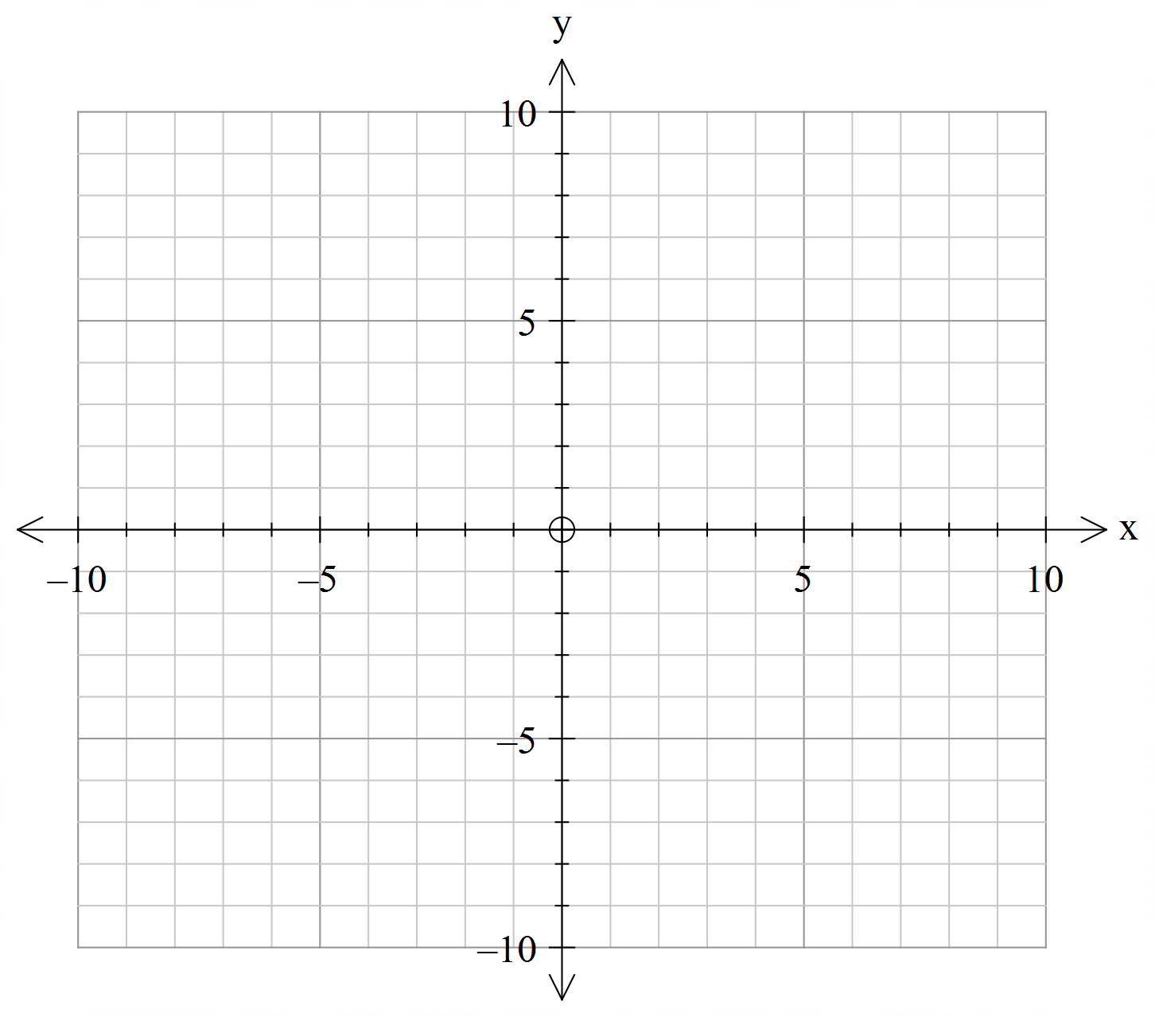

- Determine one of the intercept points of the two graphs

- Describe what type of graph each table forms

2. The equations y=x² and y=x² - 3 have been put into a table of values below. Using the axis provided, construct the graphs and then describe the difference between the two graphs. [4, 1 - 5 marks]

Y = | -2 | -1 | 0 | 1 | 2
y=x² | 4 | 1 | 0 | 1 | 4
y=x²- 3 | 1 | -2 | -3 | -2 | 1


Describe the difference:

3. Given the following tables, match the rules to the graphs [3 Marks]

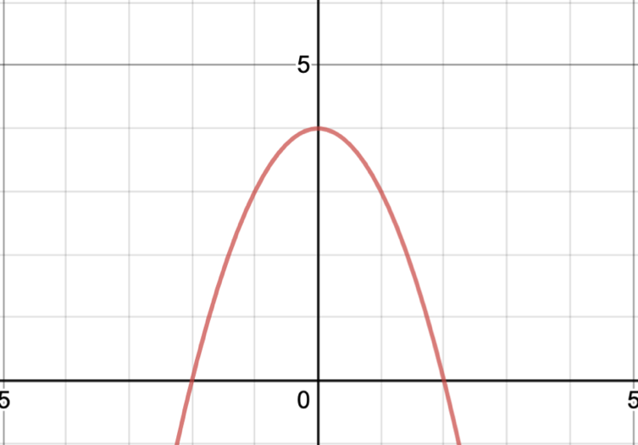
a. i.
x | -2 | 0 | 2
y | 2 | 0 | -8

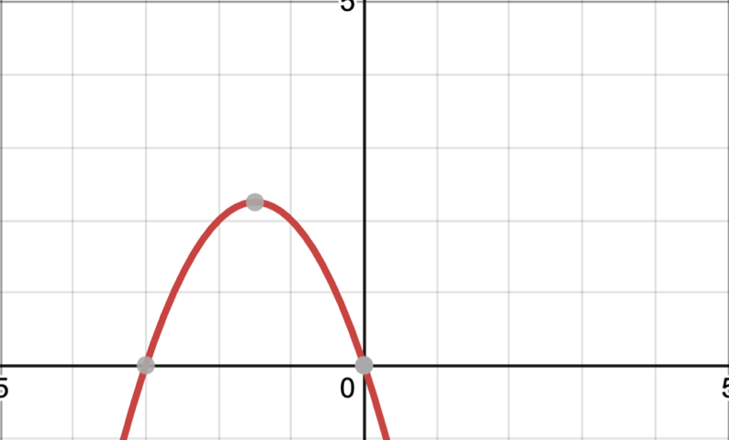
b.
ii.
x | -2 | 0 | 2
y | 0 | 0 | 10

c. iii.
x | -2 | 0 | 2
y | 0 | 4 | 0
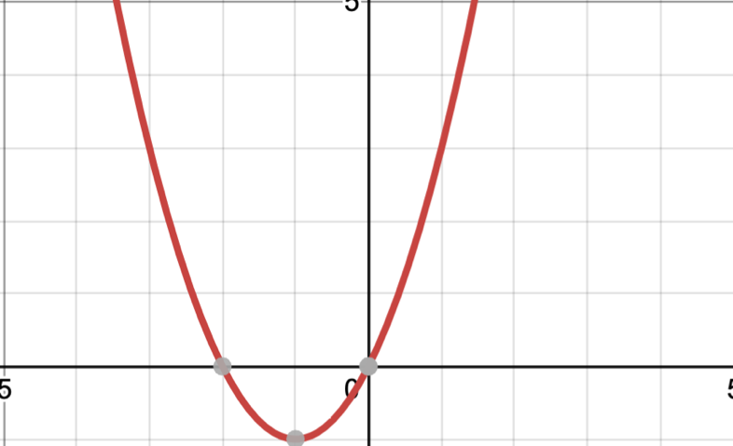

4. Write the rule below underneath their correct graphs [4 Marks]

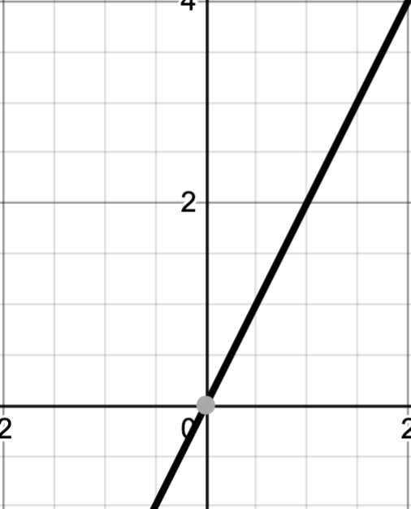
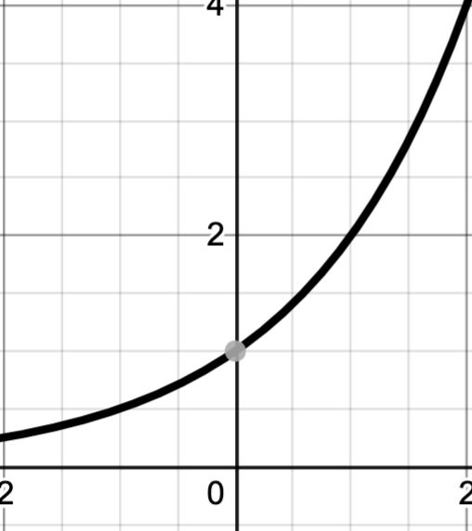
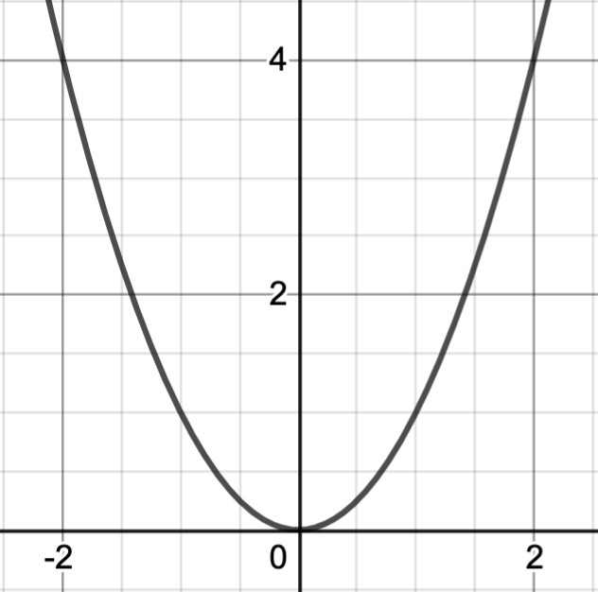
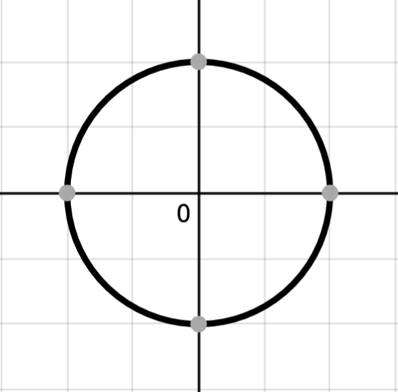
- y = 2x
- y = x²
- y = 2^{x}
- y²+x² = 4

5. Kalgoorlie has one of the largest open cut mines in the Southern hemisphere. If you tossed a rock into it, it would form an arc with the equation of h = -s² +2s +2, where h is the height in metres, and s is the time in seconds. [2, 3 - 5 marks]

a. Determine the height of the rock as it is released

b. Determine the height of the rock after 5 seconds

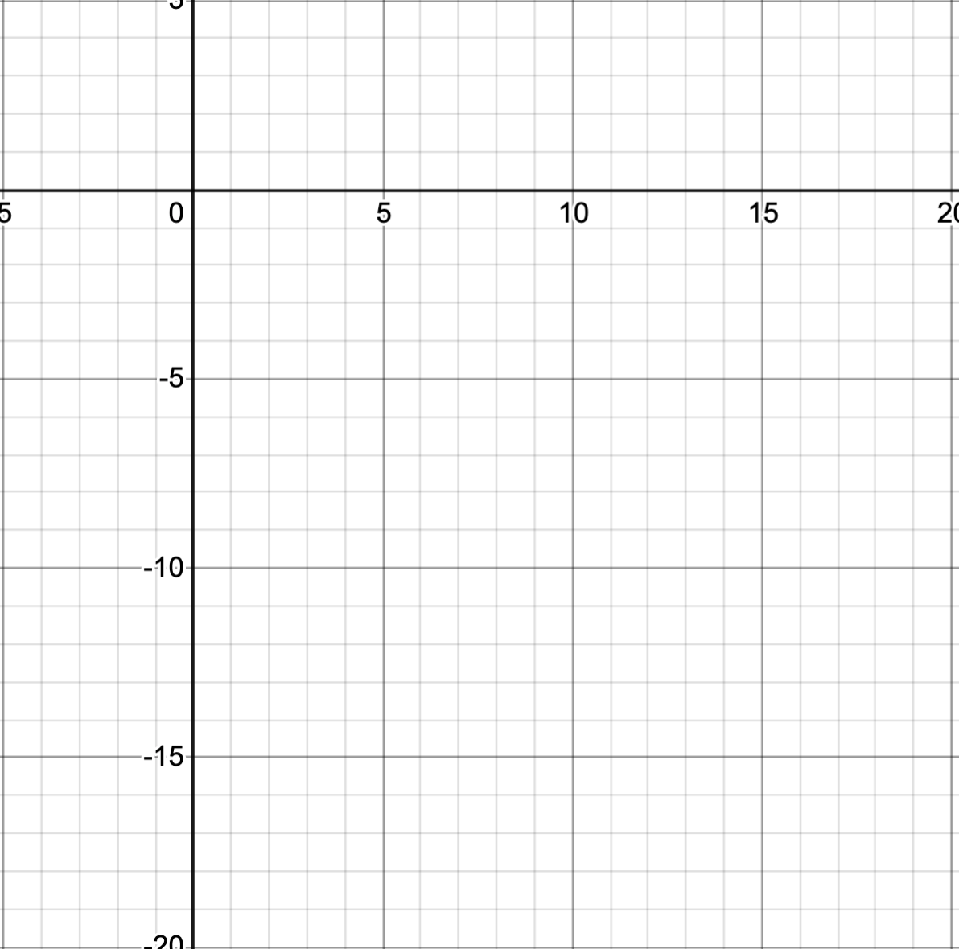

End of Test

